# Identify all the different components you know in the following motherboards.

Number 1

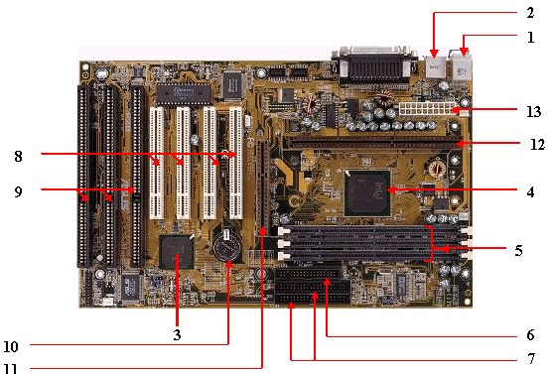

1.2. external ports

3. Southbridge

4. Northbridge

5. Triple Channel RAM slots

6. Floppy Channel

7. IDE controller

8. PCI expansion slots

9. ISA slot

10. CMOS battery

11. AGP slot

12. CPU socket (slot1, obsolete)

13. ATX 20-pin power supply plug in

Number 2

3

4

1

2

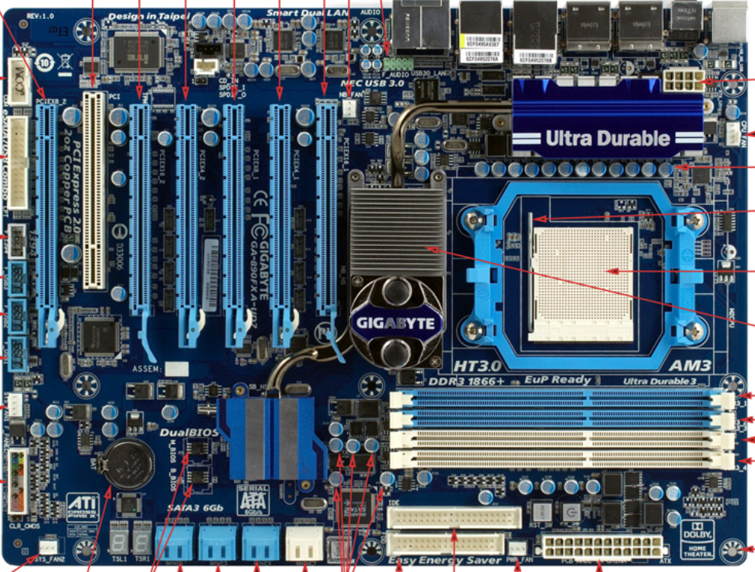

26

25

17

6

7

8

9

10

11

12

13

14

15

16

5

18

19

20

21

22

23

24

27

28

1. PCI slot

2. 4x PCIe x16 slots

3. 3-pin case fan connector

4. audio header

5. P4 8 pin CPU power

6. 4 pin CPU fan connection

7.

8. CPU socket lever

9. CPU socket

10. northbridge

11. 4 x RAM slots

12. mounting hole

13. 24 pin motherboard power connector

14. 3 pin case fan connector

15. primary ATA connector

16. floppy connector

17. capacitors

18. SATA connections

19. dual BIOS

20. CMOS battery

21. 3 pin case fan connector

22. system panels connectors

23. 4 pin case fan connector

24. 3x USB headers

25. 1394 header

26. eSata header

27.COM header

28. PCIe slot

Number 3

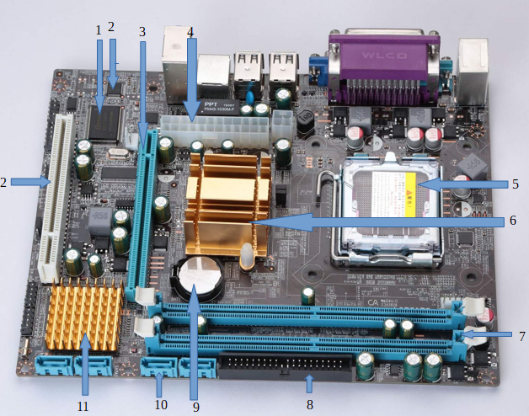

1. Flash memory BIOS

2. CMOs memory

3. PCI express x 16

4. ATX power connectors

5. CPU socket

6. northbridge

7. RAM memory slots DDR

8. PATA connector

9. CMOS backup battery

10. SATA connectors

11. southbridge

12. PCI

Number 4

12

1 2 3 4

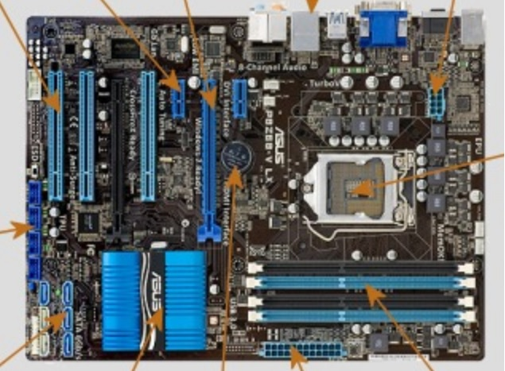

11

10

9

8

7

6

5

1. PCIe x1

2. PCIe x16

3. Rear panel ports

4. 8pin power

5. CPU

6. RAM DDR3 DIMM

7. 24 pin ATX

8. CMOS battery

9. Chipset PCH

10. SATA

11. USB

12. PCI

Number 5

Heatsink

8 pin ATX

CPU socket

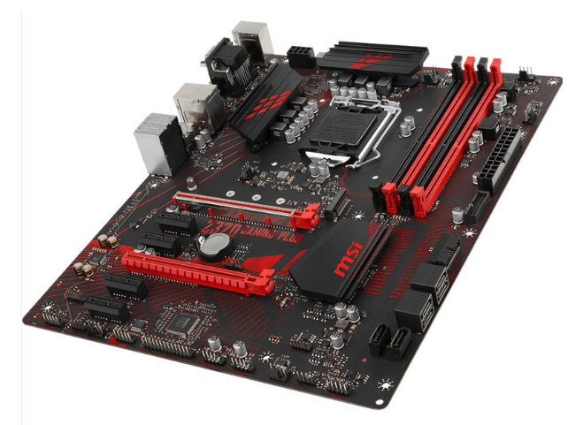

Chipset PCH

CMOS battery

PCIe 1x

SATA ports

24pin ATX

RAM DDR4

PCIe 16x

# Identify the external connectors in the following pictures

Number 1

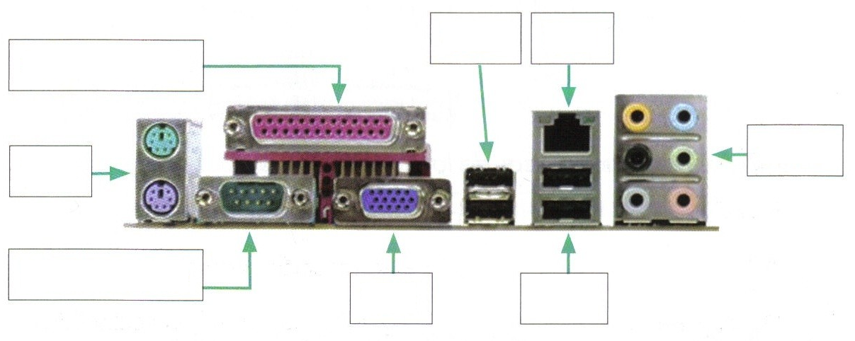

Ps/2

Serial

VGA

USB

Audio

RJ-45

USB

Parallel

Number 2

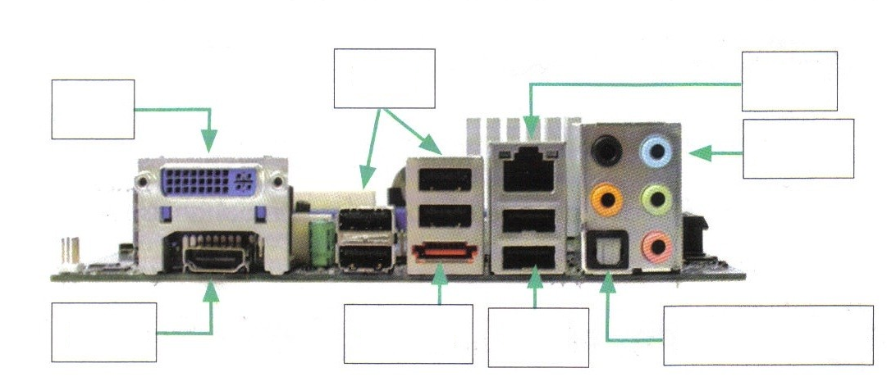

Hdmi

eSATA

USB

S/PDIF

Audio

RJ-45

USB

DVI

Number 3

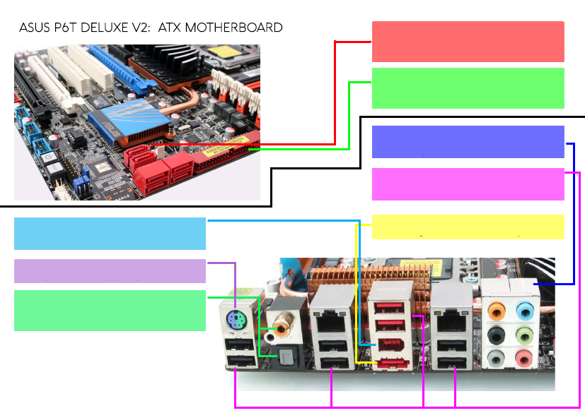

SPDIF out

PS2 port

Fireware 6pin port

eSATA

USB 2.0

Audio

IDE

SATA3

Number 4

USB

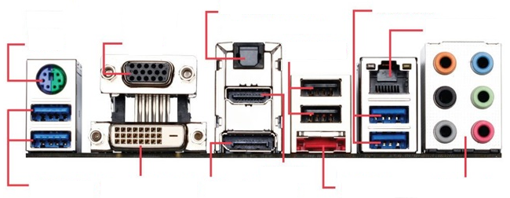

Audio

RJ-45

eSATA

HDMI

DVI

VGA

USB

Fireware 6pin port